Electric Cars
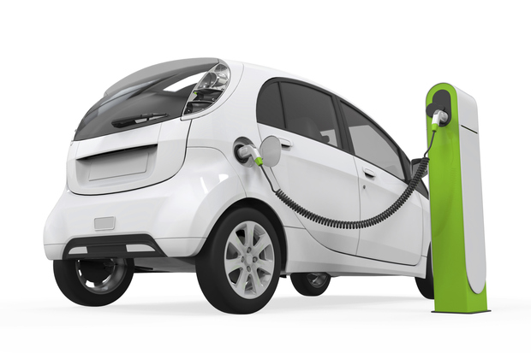
Where do cars get their energy from? For most cars the answer is petrol, but some cars run on electricity. These cars have special motors that get their power from large batteries. In addition, there are some cars that have both an electric motor and a motor which runs on petrol. These types of cars are called hybrid cars.

Most people think electric cars are an invention from the 21st century, but they have been around for a long time. In the late 19th and early 20th centuries, electric cars were popular because the technology for petrol engines was not very advanced yet. But once the petrol engine improved and became easier to produce, more and more people chose to drive on petrol fuelled cars. These types of engines became the most popular cars all over the globe.

Interest in electric cars was high in the 1970s and 1980s because oil became very expensive. Recently, electric cars have become popular again because people want cars that are better for the environment. This is because the biggest benefit of electric cars is their reduced pollution. In areas where there is a high percentage of electric cars, there is less pollution.
But, there are also other benefits of driving electric cars. The second benefit of electric cars is a reduction in the dependence on oil. There are several countries, including the United States, that don’t want to rely on oil coming from other countries. However, those countries are also worried about the dangers from drilling oil in their own country. Since electric cars can run on electricity from different metals, there is less need to import oil.

Despite these benefits of electric cars, there are some problems with them as well. One disadvantage is that electric cars are more expensive than normal cars. This is mostly due to the high cost of the batteries these cars need. Electric cars run on batteries, just like a mobile phone does. And like mobile phones, cars can be plugged in to charging stations to recharge. They need to be charged in special places though. Right now, there is a lack of places where people can charge the batteries of their electric car. People often need to install a charging station at their home, so they can charge their car overnight.
Apart from that, charging your car also takes up a lot of time; it takes 30 minutes to recharge up to 80% of its entire capacity. This takes much longer than fuelling your car with petrol at a gas station, which can be done within only a few minutes.
A second disadvantage is that some people are afraid that the battery will run out of electricity and the car will stop in the middle of the road. This could happen because electric cars cannot travel as far as petrol fuelled cars. This fear is known as ‘range anxiety’.

We don’t know what the future will bring and if more people will drive in electric cars, but we do know that we need a solution for the pollution if we want to save the environment. What do you think will happen? Will more people drive electric cars in the future?

Answer the following questions. Are the statements true or false?
- Hybrid cars are the same as electric cars. true or false?
- Electric cars were built before petrol fuelled cars. true or false?
- A disadvantage from electric cars is the high level of pollution. true or false?
- It takes 30 minutes to recharge your electric car to 80%. true or false?
- Range anxiety is the name for people’s fear of pollution. true or false?

Pollution activities

- Label the pictures with the expressions from the box
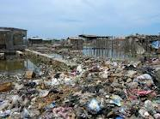


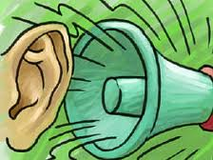
Land pollution / water pollution / air pollution / noise pollution
TYPES OF POLLUTION

- What are the effects of pollution on the environment and on the people?
Look at the labeled pictures and complete the table:

 | 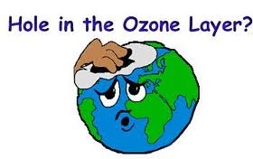 | 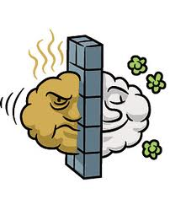 | 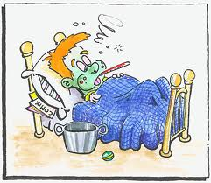 | 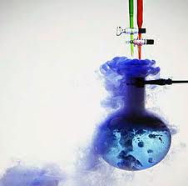 | 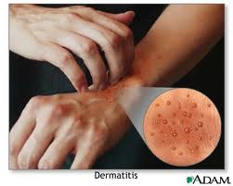
Headache | Hole in the ozone layer | Smog | Disease / sickness | Chemical reaction | Skin rash
 |  | 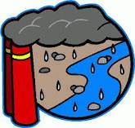 | 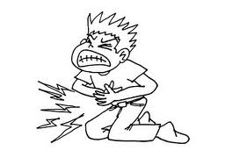 |  | 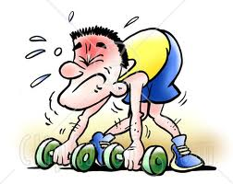
Burn | Breathing problem | Acid rain | Stomachache | Deafness | Weakness

Effects of pollution on people | Effects of pollution on the environment

- Now read text1 and text 2 and find out the causes and the effects of each type of pollution.

TEXT 1 TEXT 2
Living in noisy overcrowded towns has become dangerous because everyday exposure to noise can cause headache, earaches and may lead to deafness.
Because factories release fumes, the air people breathe gets polluted. Other well-known effects of fumes are smog, acid rain and holes in the ozone layer.

Text | Type of pollution | Causes | Effects
1 |  |  | -  -  -
2 |  |  | -  -  -
The Future House
- ……………………
Many large companies are thinking about the future. In particular, they’re thinking about how you are going to live. They are designing a home for the future that is both simple and convenient. This home is called the ‘smart’ house as it responds to your individual needs. Any questions? Let’s see if the smart house has got the answers.
- ……………………
You will have an automated wardrobe. Just key in the weather and the type of clothes you want to wear to the built-in computer, and it will suggest an outfit for you. It will even steam your clothes with a steam cleaner.
- ……………………
You will have an automated kitchen. All your appliances will be intelligent. A camera in the fridge will send a list of ingredients to the cooker’s computer, which will suggest a recipe for you to cook. The smart fridge will even write a shopping list and order food for you. Your work surface will connect with your appliances so they won’t need cords to work. And you won’t be able to burn yourself on the cooker as i twill only heat up the area which is covered with pans.
- ……………………
The lounge will be the centre of the smart home, as it is today, but will also be automated. It will have a big glass table in the middle. The table is in fact an e-table, a powerful central computer programmed for each family member’s tastes and moods. It will know what music you like, what TV programme you watch and even what pictures you would like to see on the walls.
- ……………………
The house will have a robot that knows each family member individually. It will greet you at the door and will know if there are intruders in the house. It will help you to plan your schedule or communicate with other members of the family, and it will also find and print out information for you.
- ……………………
The bathroom mirror will monitor your health and skin condition, telling the taps to dispense the right kind of water for your skin. Your toilet will analyse your urine and email your doctor if the results are worrying, and the air conditioner will kill the flu bug and other viruses.
- ……………………
The building’s computer will monitor the house’s solar batteries and tell you how much power you are consuming. The air conditioning system will recycle waste energy to cool or warm the air, and water will be supplied from recycled rain water. Of course, at the end of the day, you can still do something traditional. You can switch off the TV and turn out the lights.

READING SKILLS: Matching headings.
- Before you read the headings, identify the main idea of each paragraph.
- Read the first and last sentence in each paragraph. These usually summarise the content.
- Sometimes there is an extra heading you do not need. Check that this doesn’t match any of the paragraphs.

Questions.
- Read the article and match headings a-h to paragraphs 1-7. There is one heading you don’t need.
- How will I be able to relax?
- What effect will it have on the environment?
- What type of houses are companies designing for the future?
- What am I going to put on?
- How am I going to feed myself?
- How much will a new house cost?
- What happens if I’m not well?
- How will I organise myself?
- What will the appliances do? Match each appliance 1-8 to a function a-h.
- Air conditioning system | - Meet you at the door
- Automated wardrobe | - Choose music, TV programmes, and pictures
- E-table | - Monitor your health and skin condition
- Toilet | - Cool or warm the air and water
- Computer in the cooker | - Suggest which clothes to wear
- Robot | - Write shopping lists
- Bathroom mirror | - Suggest a recipe
- Smart fridge | - Email your doctor

- Find words or phrases in the article for these definitions.
- (par.1) Suitable and practical = ……………………
- (par.1) Of only one person = ……………………
- (par.4) How you feel = ……………………
- (par.5) Someone in your house without your permission = ……………………
- (par.6) To give out or supply = ……………………

